

Name: M. Jawad-Haider
Roll No.: SU92-BSAIM-F24-056
Section: BSAI 3-A
Subject: AI(Theory)

Step 1: Dataset Selection
I selected a Smartphone Sales dataset that contains features like:
- Brand
- Model
- RAM
- Storage
- Camera
- Battery
- Price
This dataset is good because smartphone sales depend on multiple features, and we can predict the selling price (target variable).

Step 2: Importing and Loading Dataset
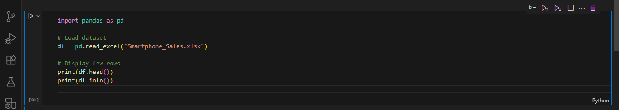

Step 3: Data Preprocessing

- Handle Missing Value
- Encode Categorical Columns (like Brand, Model)
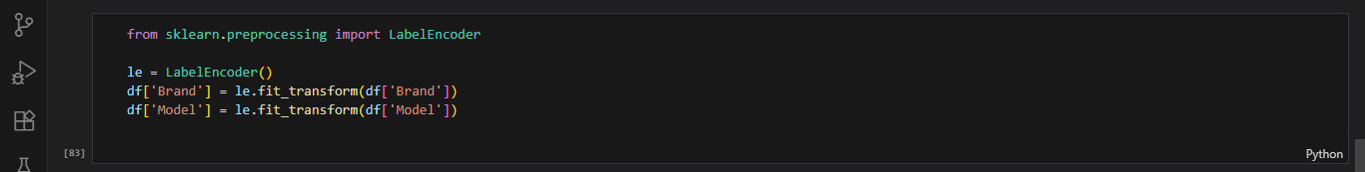
- Define Features and Target
Step 4: Train-Test Split
Step 5: Model Training (Linear Regression)
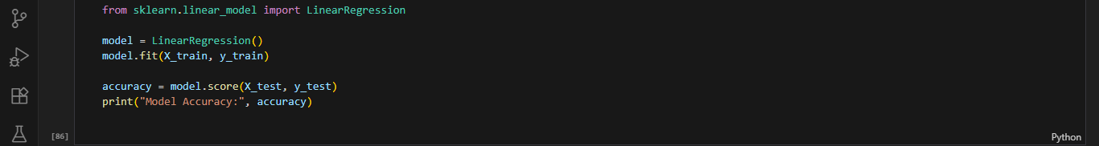
Step 6: Save the Model
Step 7: Simple Streamlit Application

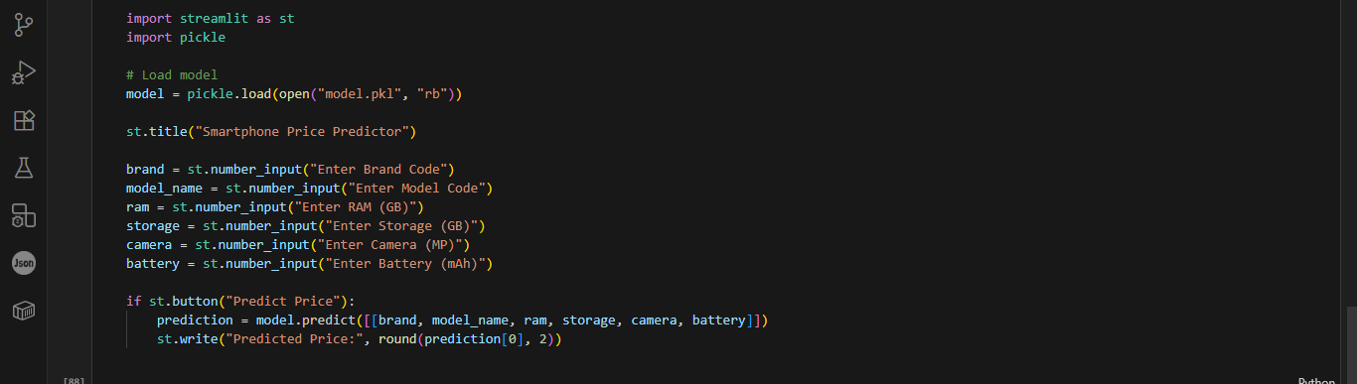
Price Prediction:
